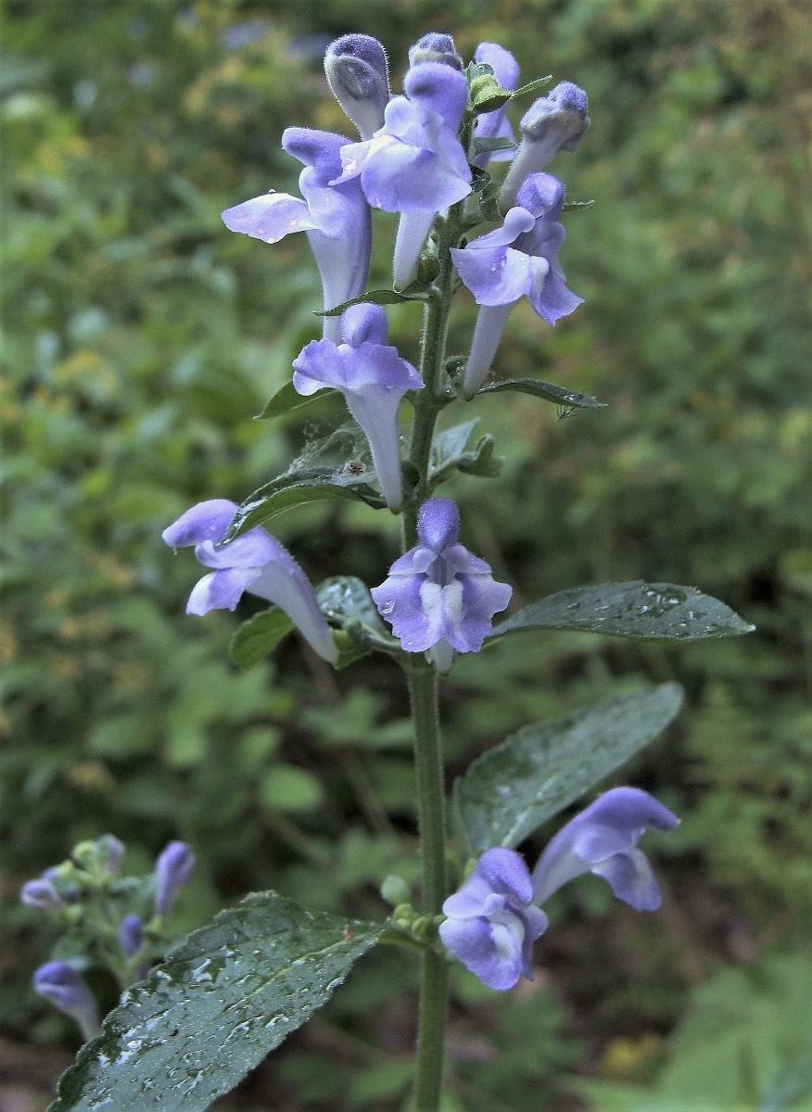
Hoary Skullcap Scutellaria incana

*Full sun to part-shade
*2ft to 4ft tall *Deer/Rabbit resistant *Showy flowers attract a variety of pollinators *Drought tolerant *potent medicinal herb *blooms throughout summer

